**COMPARISON OF THE TRAWLING CHARACTERISTICS OF THE 2018 SNOW CRAB SURVEY AND 2019 REPLACEMENT SURVEY VESSELS**

**by Tobie Surette**

**Sampling Biases of the Snow Crab Trawl Survey**

Meaningful comparisons of catch levels between areas and/or between years require that local trawl catches be **standardized**, i.e. that nuisance factors be either accounted for so as to render them negligible and that any remaining factors be stationary with respect to time or space (i.e. between years or sites).

**SEQUENCE OF EVENTS WHEN TRAWLING**

The trawl is first cast with the vessel moving at moderate speed so as to expand the trawl net and separate the trawl doors. During this period, the winch is lets out a pre-determined length of warp cable, rounded to the nearest 25 fathoms, which is closest to a target 3:1 ratio with the water depth at the fishing location. At depths exceeding 175 fathoms, a maximum warp length of 525-550 fathoms is used. The winches are then locked and the survey vessel slows to the target trawling speed of 2 knots. The trawl continues its descent through the water column, generally approaching its maximum vertical speed the minute prior to bottom contact. The trawl goes through two periods of deceleration: the first is when one or both trawl doors touch down, and then a second, stronger deceleration coincident with the contact of the footrope on the sea bottom. The trawl headline settles a further 1-1.5 meters during the first 20-30 seconds of trawling as the doors and wings stabilize to their full expanded width.

***Note:*** *Examination of different warp to depth ratios revealed no discernible trends with trawl wing spread using 2018 data.*

**SWEPT AREA**

The variable used to standardize snow crab survey catches is the surface area covered by the trawl footrope as it is dragged along the bottom. As such, it is not only a function of the distance it covers while trawling, but also the width of the footrope, which varies considerably from one site to another, depending on the water depth and vessel speed, and mostly the type of sediment, which leads to disparate levels of accumulated material in the trawl belly.

Note that when dealing with other types of trawls or analysis of non-benthic species require measures of trawling effort other than swept area. For example, in beam trawls or scallop drags, it is often sufficient to only consider the distance trawled when comparing abundance indices. Benthic fish species may require volumetric measures of trawl effort rather than areal ones.

**TRAWL TOUCHDOWN AND LIFTOFF**

The first step in estimating swept area is to define the start of the tow, which is equated as the trawl touchdown time. Initially, start times are estimated on-board the survey vessel, based on real time readings from the trawl acoustic monitoring probes. The start times are then re-estimated post-survey using recorded data from Minilog and Star Oddi probes.

Trawl end times are equated with the stop time signal given by the survey chief, at which point the survey vessel generally slows and trawl winches are activated. In contrast with the trawl start times, trawl end times are presently not revised post-survey, leading to a short period where the trawl has not yet lifted from the bottom, yet is possibly being further dragged along the bottom, which is called the **passive trawling phase**. Likewise, the period between the trawl start and stop times is referred to as the active trawling phase.

The speed of the trawl along the bottom is not directly observed. However, during active trawling, where the cable winches are locked and the vessel steams at about 2 knots, we assume that the trawl and vessel speeds are equal.

In practice, the trawl may show backwards and forwards motion due to corresponding motions of the survey vessel or bobbing due to weather conditions. In addition, bottom gradients may lead to increases or decreases in trawl speed during trawling.

Despite variations at particular instants in time, we assume most of these instantaneous effects to average out during active trawling, so that overall estimates of distance and trawl speed are fairly reliable in any particular tow.

**WING SPREAD**

The other variable required for swept area estimation is the width of the footrope at each instant during trawling.

It is inferred through distance measurements using a pair of acoustic probes mounted on either side of the trawl wings, called **wing spread**.

Wing spread in the survey trawl is known to vary as a function of trawl speed, vessel winch configuration and the type of bottom. In particular, the accumulation of debris in the cod-end leads to much increased dragging forces which lead to increased tension in the warp cables, which in turn lead to large reductions in the trawl door and wing spreads, on the order of 50% to 70%.

This implies that swept area estimates are highly dependent on the evolution and quantity of accumulated debris during trawling.

Noisy or missing wing spread observations thus lead to estimates of swept area which have a high degree of associated uncertainty.

**IMPLCATIONS FOR TOUCHDOWN AND LIFTOFF ESTIMATION FROM 1990 TO 2013**

This sequence of events, pieced together from analysis of empirical data, is relevant when considering the historical snow crab data series up to 2013, which only had a Minilog TD recorder attached to the head line to determine the trawl touch down and liftoff times.

Minilog data have two main issues with respect to inferring trawl touchdown times. Firstly, bottom contact of the footrope precedes the settling of the headline, leading to a possible bias when estimating trawl start times from a headline-mounted probe. Secondly, the depth/pressure measurements from Minilog probes are much more imprecise, being rounded to the nearest 2 or 4 meters in some cases, which in turn leads to uncertainties in the derived start time estimates.

***Note:*** *It would be possible to estimate the amount of uncertainty by using 2014-2019 headline depth/pressure data from a Star Oddi probe, round it down to the nearest 2 or 4 meters, then compare the estimate touchdown and liftoff times with those obtained from analysis of the tilt probe data. This approach can be used to derive the most appropriate method to analyze the 1990-2013 Minilog data, i.e. the most precise and accurate, relative to the tilt data.*

**GLOSSARY**

* **Swept area**: The total surface area of the sea bottom covered by the trawl footrope at a given sampling station. It is the only variable presently used to standardize snow crab catches.
* **Descent phase**: The period during which the trawl descends the water column, the terminal approach speed is mainly a function of the size and weight the trawl doors and the speed of the survey vessel.
* **Touchdown time**: The time at which the trawl initially touches the sea bottom and active trawling begins. While the trawl doors are the first to touch the sea bottom, the start time of the tow is here defined as the first significant contact of the trawl footrope and the sea bottom.
* **Trawl end time**: The time at which active trawling is assumed to end. This is usually equated with an on-board stop signal given by an on-board representative of DFO Science, whereupon the trawl winches are activated and the survey vessel generally slows down.
* **Liftoff time**: The time at which where the footrope of the trawl leaves the sea floor during winching of the trawl.
* **Active trawling phase**: The period between the touchdown time and the trawl end time. During this phase, the survey vessel is near its target fishing speed and actively pulling the trawl along the sea bottom.
* **Passive trawling phase**: The period between the trawl end time and the trawl liftoff time. During this phase, forward motion of the vessel or other vessel manoeuvres, winching of the tow cables, sloping bottom gradients may unintentionally lead to additional movement of the trawl which is not presently accounted for in the swept area estimate.
* **Bottom phase**: The total period represented by the active and passive trawling phases.
* **Ascent phase**: The period during which the trawl footrope leaves the bottom and the trawl net is ascends through the water column and approaches the survey vessel.
* **Winch activation**: Winches are activated and begin winding the warp cable just after the stop signal is given.
* **Door touchdown**: The time at which the trawl doors make contact with the sea bottom in the period before the trawl footrope touches down.

**CATCH STANDARDIZATION**

1. **Swept area** : The main standardization variable used to standardize catches from the annual snow crab survey, swept area represents is defined as the total surface area covered by the trawl as it is dragged along the sea bottom. Accurate estimation of this value requires estimates of the start and end times of the trawling phase, the speed of the trawl as well as the width or spread of its opening at during trawling. Given the short duration of tows, small biases in start or end times bring about corresponding biases in local density estimates. For example, a 30 second bias in either the start or end time corresponds to about a 10% bias in the observed local density for a tow of 5 minute-long tow, the target duration for this survey.
   1. **Trawl start time** : This value is readily estimable from depth-pressure probes attached to either the trawl headline and footrope, as well as from a tilt-angle probe attached the trawl footrope. The start of trawling is taken to be synonymous with the trawl touchdown.
   2. **Trawl end time** : The time at which the trawl effectively stops moving, if it stops at all prior to liftoff from the bottom, is not precisely known. Currently, the end time is equated with the survey chief’s stop signal, at which point the vessel slows and the trawl cable winches are activated.
   3. **Trawl speed** : The speed of the trawl net during active trawling is not directly observed. We assume equality between the speed of the survey vessel and the trawl when the following assumptions hold: 1) The survey vessel is steams at a relatively constant speed-over-ground, 2) the survey vessel follows a relatively straight line path, 3) that the trawl winches are locked, and 4) the bottom topography is relatively smooth with a negligible slope, and 5) water currents are constant over the length of the tow. Where significant violations of these assumptions occur, trawl speed may deviate from vessel speed. Notably, the speed and orientation of the trawl is not known during the passive trawling phase, owing to
      1. winch activation which may result in passive trawling/dragging prior to liftoff
      2. slight delays in cutting the throttle after the recorded stop signal,
      3. forward momentum of the survey vessel.
   4. **Tow width** : Swept area estimation requires that width of the trawl opening be known at each instant during the trawling phase. Measurements are made by a pair of acoustic probes, one on either side of the trawl wings, which are then relayed to the survey vessel’s receiver in real time. Errors in this value include:
      1. *Measurement precision* : Vibration and probe mis-orientation result in trawl width values which may be contaminated with significant proportions of noise and outlier values.
      2. *Observation bias* : Improper or inconsistent probe placement with respect to the portion of the footrope which is assumed to make bottom contact can result in significant biases.
      3. *Missing values* : Tows with partial of totally missing or invalid trawl width measurements are generally not independent of time or the trawl location, as water depth and bottom type are known to affect the strength and quality of the measurements and signal.
      4. *Trawl asymmetry*: If the two warp cables have unequal lengths, the positioning of the trawl wings or doors will be asymmetrical and the effective tow width will be less than the one measured by the wing spread distance probes.
2. **Catchability** : Catchability in this context refers to factors which affect the probability of a given organism to enter the trawl net. For benthic organisms,
   1. **Vessel speed** : The speed of the vessel can change the level of contact of the trawl footrope. During the trawling, strong ocean conditions may also induce periodic forward and back ward fluctuations in vessel speed which can induce sympathetic motions of the trawl.
   2. **Vessel power** : Increased vessel weight and engine power imply more forceful forward movement of the footrope when encountering resistance, such as accumulating sediment and large stones.
   3. **Trawl configuration** : Factors such as entangled warp cables or sub-optimal door placement can result in decreased wing spread or poor contact of the footrope on the sea bottom.
   4. **Wave action** : In strong weather conditions, wave action may lead to significant vertical as well as horizontal movements of the survey vessel, which may lead to a decrease in bottom contact of the foot rope from the sea bottom.
   5. **Bottom type** : Bottom hardness affects the ability of the trawl footrope to dig into the sediment, possibly leading to differential catchability, especially for smaller organisms.
   6. **Large debris** : Large rocks or boulders caught at the trawl entrance may inhibit or at least modify the entry of incoming organisms.
   7. **Size effects** :
   8. **Footrope contact** : The contact of the footrope along its length may vary due to variation of tension in the bridles. Presently only the middle of the footrope with the attached tilt mechanism is characterized.
3. **Selectivity** : Refers to variable retention rates between different species, sexes or sizes.
   1. **Netting** : While the trawl construction is more or less constant, changes in the configuration of the trawl by construction or accumulation of debris can lead to elongation or contraction of its various mesh elements, which can affect their selectivity with respect to different sized organisms.
   2. **Debris** : Depending on the bottom, large quantities of sediment, mud cobble may accumulate in the trawl net, which can lead to increased retention of smaller individuals which might have otherwise have been small enough to pass through the trawl netting.
   3. **Net damage** : Though tows with major net damage are rejected and redone, minor net damage incurred during valid tows can lead to loss of catches, which lowers catch retention and thus selectivity.
4. **Sampling** : Biases in this category are
   1. **Sorting** : Smaller organisms may be overlooked by samplers when removing excess sediment, mud, pebbles and rocks which often accumulate in the trawl cod-end or by work time limits allotted between tows.
   2. **Crushing or damage** : Organisms crushed or mangled during trawling may be unmeasurable (e.g. missing carapace or claws in snow crab) or may be uncountable if only fragments of the original organism remain.

**ASPECTS OF PRESSURE/DEPTH**

* Touchdown estimation.

**TEMPERATURE ESTIMATION**

* Bottom temperatures at each trawling station are measured by a Minilog TD and Star Oddi TD probes attached to the trawl headline as well as a Star Oddi Tilt-TD probe attached to the footrope.
* Some time is required for these probes to equilibrate with the ambient temperature, thus temperatures are usually determined using data from the last few minutes of the tow.
* We note that the Star Oddi probe on the footrope does not equilibrate well, as its stainless steel casing inhibits the exchange of ambient temperature water onto the probe, especially given the quantity of accumulated sediment frequently encountered by the footrope. This issue is most prevalent in shallow waters, ostensibly due to the shorter length of time during the trawl descent.
* Thus only headline TD provide water temperatures and their height generally lies about 1.2-1.5 meters over the sea bottom.
* We also note that Minilog TD probes seem to require a longer thermal stabilisation period than Star Oddi probes, which may imply some bias in past estimates of bottom temperature, which relied on these probes.
* We note that in deep waters, where there is a supposed longer time period for the Minilog probe to thermally stabilise, the temperature difference between it and the Star Oddi probe tends to be limited to 0.1 degrees.

**TOTAL SURVEY MEASUREMENTS AND SAMPLES**

* 18046 fish measured (46 different species)
* X species and taxa identified
* 52244 crab measured
* X CTD casts
* X colorimeter measurements
* X egg pouches sampled.
* 352 successful tows and 40 die-by-side comparative tows.

**TRAWL JUMPING**

* Standardizing catches via swept area requires that bottom contact of the trawl footrope along the span reported by the wing spread probes be fairly constant between tows.
* Fishing during high seas, rough bottom topography, are known to temporarily vary the level of contact of the trawl door to the sea bottom.
* In particular, the variability of the trawling speed on-board the 2019 survey vessel raises questions about its possible effects on trawl behaviour.
* The various probes on the trawl can be used to quantify such effects at their attachment points.
* For instance, in tows with large vessel speed fluctuations, there are in some cases, small sympathetic fluctuations in the headline, up to 0.6 meters in amplitude, though these only seem to occur in the most extreme cases.
* However, in such cases, there were no discernible fluctuations in the footrope probe.
* Similarly, the tilt angle of this probe showed no departures from its normal trawling variation.

**DATA SOURCES**

Devices :

* *eSonar* : Acoustic trawl measurement system used since 2013. Provides measurement of trawl headline depth, headline height from the bottom, trawl wing spread separation,
* *Minilog* : Temperature / depth probes used since 1990 with the last probe ceasing to function in the early part of the 2019 survey. Low resolution depth / pressure.
* Star Oddi : In use since 2013, these probes provide higher resolution temperature and pressure readings. The
  + Star Oddi :
  + Flowmeter :
* Star Oddi probes during the sampled at a rate of once per second.
* **Pressure** : For some purposes, pressure can be linearly rescaled to some estimate of water depth in order to get absolute measures of vertical movement.
* **Temperature** : The headline and footrope both measure ambient water temperature. However, water temperatures from the footrope probe are less suitable for inferring bottom water temperatures since its protective casing largely prevents the probe from equilibrating to the bottom temperature over the five minutes of trawling.
* **Tilt** : The footrope probe contains internal accelerometers which are converted to x, y, and z tilt angles. The x angle, the angle of the probe’s central axis with respect to the plane perpendicular to the Earth’s gravitational force, is the one used for inferring the trawl touchdown and liftoff times.
* **Compass** : During the comparative survey, footrope tilt probes contained a magnetic compass which measured heading of the tilt probe, which is perpendicular to the footrope.
* **Flowmeter** : A Doppler single-point flowmeter was attached and yielded usable water current data in 17 tows during the comparative survey. The probe was attached underneath the headline. The total current flow



**Figure X** : Effects of large fluctuations in the survey vessel speed. The left-hand panel shows large cyclic variations in vessel speed while the right-hand panel shows a large perturbation encountered during rough sea conditions, leading to a large temporary deceleration and recovery to nominal trawling speed.

* The top row shows the survey vessel speed during trawling.
* The second row shows the variation in the headline depth, as recorded by a Star Oddi pressure sensor.
* Similarly, the third row shows the variation in the footrope depth, as recorded by a Star Oddi pressure sensor.
* The bottom row shows the tilt angle.

**Note that this does not rule out …**

* **Skipping at the edges of the footrope ( as there are no probes there)**

**Table 1** : Summary of survey vessels, acoustic trawl sensor monitors and attached temperature/depth (TD) and tilt angle recorders.

|  |  |  |  |  |  |  |  |  |  |
| --- | --- | --- | --- | --- | --- | --- | --- | --- | --- |
|  | **Survey Vessel** | | | | **Trawl** | | **Minilog** | **Star-Oddi** | |
| **Year** | **Name** | **Length(ft)** | **Horsepower** | **Type** | **Method** | **Sensor** | **TD** | **TD** | **TD-Tilt** |
| 1988-1989 | Emy Serge D. | 64 | 375 | wood | side | - | - | - | - |
| 1990-1998 | Emy Serge D. | 64 | 375 | wood | side | Scanmar | **X** | - | - |
| 1999-2002 | Den C. Martin | 64 | 402 | steel | stern | Netmind | **X** | - | - |
| 2003-2012 | Marco-Michel | 65 | 660 | fiberglass | stern | Netmind | **X** | - | - |
| 2013 | Jean-Mathieu | 65 | 720 | steel | stern | eSonar | **X** | - | - |
| 2014-2018 | Jean-Mathieu | 65 | 720 | steel | stern | eSonar | **X** | **X** | **X** |
| 2019 | Avalon Voyager II | 65 | 850 | steel | stern | eSonar | - | **X** | **X** |

**Table 2:** Potential systematic biases identified for the annual snow crab trawl survey. Shown are the expected impact of each type of bias on abundance or biomass estimates, the probable sign of their impact on abundance or biomass indices, their potential magnitude as well as their descriptions or additional comments.

|  |  |  |  |  |  |
| --- | --- | --- | --- | --- | --- |
| **Subject** | **Variable** | **Aspect** | **Sign** | **Magnitude** | **Description or comments.** |
| **Swept area** | **Active trawling** | Touchdown time | +/- | slight | Difference between the observed touchdown time and the true touchdown time. Corrected using trawl probe data. |
|  |  | Stop time | +/- | slight/moderate | Time when stop signal is given. |
|  | **Passive trawling** | End time | + | slight/moderate | Time when trawling effectively ends (unknown). |
|  |  | Vessel direction | +/- | slight/moderate | Vessel manoeuvres affect the duration and spatial extent of latent trawling. |
|  |  | Vessel speed | +/- | moderate | Faster vessel speed affects the efficiency and length of the latent trawling phase. |
|  |  | Winching | +/- | slight | Faster winch speed leads to shorter latent phase. |
|  | **Tow width** | Measurement precision | +/- | slight | Acoustic readings are often noisy and/or missing. |
|  |  | Observation bias | +/- | slight | Variation in trawl probe placement, though clips are generally in the same position from year to year. |
|  |  | Trawl asymmetry | - | slight/moderate | Cable twisting or differences in warp cable length lowers effective trawl width. |
|  |  | **Foot rope** | +/- | unknown | Contact at edges of trawl may be more variable than the central part. |
| **Catchability** | **Vessel** | Speed | - | slight | May reduce level of footrope contact . |
|  |  | Power | +/- | slight/moderate | Changes how trawl slows when encountering obstacles. |
|  |  | Movement | +/- | slight/moderate | Back and forth or vertical movement can decrease of even increase bottom contact. |
|  | **Sea bottom** | Hardness | - | slight/moderate | Hardness of bottom may decrease footrope contact. |
|  |  | Large debris | - | Tow-specific | Debris at trawl mouth may affect entry into trawl. |
|  | **Animal** | Size/behaviour effects | - | slight/moderate | Smaller, low-lying, burrowing or crouching animals may be caught less. Environmental variables can affect behavior. |
|  |  |  |  |  |  |
| **Selectivity** | **Netting** |  | +/- | slight | Variation in trawl netting may affect retention. |
|  | **Debris** |  | + | moderate | Smaller organisms may be preferentially retained in catches with heavy sediment debris. |
|  | **Net damage** |  | - | slight/moderate | Smaller holes in trawl net can lead to some loss of catches. |
| **Sampling** | **Station sampling** | Relocation of survey stations | +/- | slight/moderate | Survey stations are progressively relocated to more suitable trawling bottom. Softer bottoms may lead to increased catchability. |
|  | **Animal size** |  | - | slight | Loss of very small organisms within discarded matrix sediment or rocks. |
|  | **Damaged animals** |  | - | slight | Samples lost or unanalyzable due to damage (e.g. crushed carapace, claws, etc…). |

|  |  |  |  |  |  |  |  |  |  |  |  |  |  |  |  |  |  |  |  |  |  |  |  |  |  |  |
| --- | --- | --- | --- | --- | --- | --- | --- | --- | --- | --- | --- | --- | --- | --- | --- | --- | --- | --- | --- | --- | --- | --- | --- | --- | --- | --- |
|  | **Depth (fathoms)** | | **Temp** | | **Swept area** | | | | **Passive duration (s)** | | **Snow crab** | | | | | | | | | |  |  |  |  |  |  |
| **Tow ID** | **(degrees)** | | **Value** | | **Std. Dev.** | | **COM** | | **MM** | | **MI** | | **FM** | | **FI** | | **cod** | | **plaice** | | **urchin** | |
|  | **AV** | **JM** | **AV** | **JM** | **AV** | **JM** | **AV** | **JM** | **AV** | **JM** | **AV** | **JM** | **AV** | **JM** | **AV** | **JM** | **AV** | **JM** | **AV** | **JM** | **AV** | **JM** | **AV** | **JM** | **AV** | **JM** |
| 330 | 50 | 49 | 2.6 | 2.2 | 3009 | 2557 | 46 | 183 | 86 | 66 | 3 | 2 | 8 | 12 | 43 | 64 | 23 | 7 | 12 | 33 | 55 | 46 | 41 | 19 | 4 | 2 |
| 336 | 58 | 59 | 3.2 | 3.1 | 2613 | 2672 | 22 | 213 | 26 | 73 | 3 | 8 | 6 | 13 | 25 | 30 | 0 | 0 | 0 | 5 | 4 | 11 | 91 | 138 | 3 | 0 |
| 327 | 55 | 56 | 2.8 | 2.8 | 3003 | 3167 | 15 | 218 | 98 | 79 | 9 | 12 | 15 | 19 | 36 | 20 | 0 | 0 | 5 | 5 | 13 | 11 | 243 | 102 | 0 | 2 |
| 332 | 62 | 60 | 3.4 | 3.1 | 3950 | 3669 | 29 | 59 | 42 | 60 | 9 | 8 | 15 | 15 | 33 | 65 | 0 | 0 | 1 | 1 | 13 | 3 | 62 | 140 | 1 | 1 |
| 322 | 53 | 54 | 2.6 | 2.6 | 2930 | 3709 | 100 | 286 | 26 | 23 | 11 | 18 | 17 | 28 | 15 | 34 | 83 | 228 | 2 | 0 | 39 | 33 | 184 | 198 | 9 | 41 |
| 319 | 46 | 44 | 2.8 | 2.5 | 2841 | 2793 | 25 | 28 | 15 | 78 | 1 | 2 | 9 | 21 | 4 | 130 | 9 | 61 | 1 | 59 | 21 | 65 | 14 | 89 | 23 | 316 |
| 304 | 37 | 36 | 2 | 2 | 2889 | 2906 | 17 | 16 | 78 | 30 | 3 | 7 | 24 | 20 | 38 | 56 | 240 | 269 | 48 | 6 | 3 | 17 | 286 | 207 | 1 | 1 |
| 318 | 56 | 56 | 2.3 | 2.1 | 2488 | 2672 | 12 | 222 | 23 | 97 | 5 | 6 | 16 | 13 | 68 | 45 | 8 | 130 | 3 | 9 | 193 | 194 | 106 | 121 | 28 | 296 |
| 309 | 34 | 34 | 1.9 | NA | 2682 | 2389 | 11 | 15 | 94 | 44 | 7 | 4 | 16 | 7 | 47 | 41 | 20 | 19 | 5 | 4 | 11 | 21 | 100 | 198 | 4 | 5 |
| 302 | 33 | 34 | 2.1 | 2 | 3036 | 2819 | 17 | 20 | 35 | 36 | 6 | 2 | 71 | 26 | 81 | 142 | 58 | 7 | 39 | 0 | 18 | 9 | 266 | 171 | 5 | 29 |
| 288 | 34 | 35 | 2.1 | 2 | 2869 | 2895 | 12 | 13 | 73 | 29 | 17 | 7 | 51 | 29 | 79 | 57 | 86 | 62 | 23 | 14 | 41 | 31 | 186 | 97 | 86 | 331 |
| 291 | 32 | 32 | 2.2 | 2.1 | 3606 | 3365 | 17 | 201 | 15 | 30 | 2 | 4 | 14 | 17 | 15 | 26 | 123 | 163 | 1 | 7 | 7 | 16 | 108 | 139 | 20 | 105 |
| 296 | 26 | 26 | 1.7 | NA | 2670 | 2719 | 147 | 250 | 61 | 19 | 2 | 6 | 19 | 18 | 114 | 65 | 47 | 55 | 20 | 7 | 28 | 17 | 100 | 147 | 39 | 73 |
| 297 | 25 | 25 | 1.1 | 1 | 2345 | 2845 | 13 | 12 | 30 | 23 | 2 | 7 | 7 | 25 | 26 | 89 | 0 | 9 | 4 | 14 | 16 | 18 | 154 | 139 | 10 | 68 |
| 307 | 31 | 32 | 2.2 | 2.1 | 3189 | 3235 | 14 | 64 | 71 | 33 | 2 | 0 | 17 | 4 | 29 | 20 | 62 | 77 | 4 | 6 | 71 | 50 | 321 | 101 | 56 | 129 |
| 305 | 44 | 44 | 3.2 | 3.1 | 2794 | 3048 | 17 | 27 | 39 | 6 | 1 | 10 | 7 | 25 | 4 | 7 | 126 | 200 | 3 | 3 | 57 | 59 | 107 | 51 | 31 | 68 |
| 306 | 55 | 55 | 3.1 | 2.8 | 1556 | 1794 | 73 | 72 | 85 | 80 | 6 | 9 | 10 | 20 | 44 | 97 | 0 | 0 | 2 | 0 | 0 | 0 | 15 | 16 | 0 | 0 |
| 299 | 37 | 55 | 2.6 | 2.5 | 2348 | 4859 | 15 | 72 | 83 | 174 | 11 | 19 | 29 | 69 | 27 | 81 | 253 | 476 | 0 | 52 | 8 | 8 | 317 | 229 | 0 | 0 |
| 283 | 40 | 40 | 2 | 2 | 4050 | 3235 | 30 | 15 | 74 | 72 | 7 | 5 | 38 | 30 | 96 | 115 | 91 | 90 | 13 | 16 | 3 | 3 | 282 | 208 | 2 | 5 |
| 274 | 33 | 35 | 1.2 | 1.1 | 2983 | 2496 | 25 | 15 | 78 | 63 | 2 | 3 | 32 | 48 | 116 | 113 | 3 | 9 | 47 | 22 | 156 | 683 | 142 | 75 | 56 | 40 |
| 286 | 33 | 34 | 1.5 | 1.4 | 2686 | 2825 | 27 | 16 | 38 | 40 | 12 | 16 | 21 | 37 | 56 | 78 | 12 | 31 | 6 | 6 | 1 | 0 | 157 | 134 | 1 | 1 |
| 292 | 34 | 33 | 2.2 | 2.1 | 3018 | 2384 | 38 | 36 | 46 | 36 | 10 | 6 | 13 | 7 | 30 | 13 | 31 | 48 | 0 | 1 | 0 | 0 | 78 | 73 | 0 | 0 |
| 298 | 32 | 32 | 2.4 | 2.3 | 3045 | 2945 | 31 | 31 | 89 | 28 | 6 | 14 | 14 | 22 | 2 | 26 | 22 | 114 | 0 | 41 | 61 | 17 | 25 | 20 | 27 | 299 |
| 289 | 34 | 35 | 2.4 | 2.4 | 2133 | 2022 | 22 | 18 | 70 | 44 | 4 | 4 | 5 | 9 | 19 | 58 | 34 | 41 | 1 | 2 | 0 | 1 | 19 | 18 | 0 | 0 |
| 280 | 30 | 30 | 2.5 | 2.4 | 3099 | 3128 | 25 | 17 | 43 | 59 | 11 | 4 | 12 | 10 | 61 | 62 | 1 | 2 | 16 | 22 | 0 | 0 | 73 | 36 | 0 | 1 |
| 272 | 23 | 22 | 3.8 | 4.1 | 2485 | 3360 | 11 | 19 | 71 | 95 | 0 | 0 | 1 | 0 | 1 | 0 | 0 | 0 | 2 | 1 | 309 | 226 | 54 | 49 | 68 | 91 |
| 267 | 22 | 23 | 4.8 | 4.8 | 2296 | 2471 | 13 | 10 | 25 | 49 | 0 | 0 | 0 | 0 | 0 | 1 | 0 | 0 | 0 | 0 | 35 | 37 | 57 | 24 | 29 | 49 |
| 256 | 22 | 22 | 5.4 | 5.2 | 3639 | 3238 | 22 | 17 | 20 | 45 | 0 | 0 | 0 | 0 | 1 | 4 | 0 | 0 | 3 | 5 | 16 | 9 | 36 | 38 | 0 | 0 |
| 254 | 27 | 27 | 4 | 3.9 | 2261 | 2383 | 13 | 38 | 13 | 86 | 2 | 0 | 5 | 6 | 33 | 42 | 0 | 0 | 12 | 3 | 2 | 2 | 16 | 53 | 0 | 0 |
| 276 | 29 | 32 | 2.6 | 2.5 | 1691 | 2320 | 11 | 26 | 13 | 21 | 2 | 5 | 4 | 10 | 33 | 68 | 0 | 0 | 7 | 8 | 5 | 4 | 9 | 18 | 0 | 0 |
| 266 | 27 | 27 | 3.6 | 3.5 | 2250 | 2096 | 35 | 15 | 15 | 100 | 0 | 3 | 0 | 4 | 1 | 6 | 0 | 0 | 0 | 2 | 0 | 1 | 9 | 15 | 0 | 0 |
| 277 | 27 | 27 | 3.5 | 3.3 | 2100 | 2226 | 12 | 32 | 26 | 55 | 1 | 0 | 1 | 0 | 6 | 0 | 0 | 0 | 1 | 0 | 0 | 0 | 32 | 45 | 0 | 0 |
| 284 | 30 | 30 | 2.6 | 2.6 | 2087 | 2206 | 12 | 21 | -40 | 37 | 2 | 0 | 4 | 3 | 32 | 45 | 0 | 0 | 1 | 7 | 0 | 0 | 13 | 19 | 0 | 0 |
| 294 | 22 | 21 | 6.9 | 7.9 | 2866 | 2758 | 18 | 15 | 34 | 15 | 1 | 0 | 1 | 0 | 12 | 0 | 0 | 0 | 0 | 0 | 49 | 40 | 10 | 27 | 1 | 0 |
| 301 | 26 | 26 | 4.4 | 6.2 | 2427 | 3228 | 12 | 31 | 15 | 26 | 0 | 0 | 2 | 0 | 44 | 7 | 0 | 0 | 31 | 1 | 8 | 69 | 7 | 1 | 1 | 2 |
| 340 | 80 | 80 | 5.9 | 5.9 | 1961 | 1918 | 21 | 36 | 74 | 41 | 7 | 4 | 9 | 4 | 34 | 32 | 0 | 0 | 0 | 0 | 0 | 0 | 63 | 99 | 1 | 0 |
| 317 | 42 | 42 | 2.1 | 2 | 2973 | 2928 | 30 | 85 | 77 | 20 | 11 | 3 | 34 | 17 | 7 | 4 | 200 | 272 | 0 | 0 | 14 | 32 | 263 | 13 | 11 | 73 |
| 311 | 32 | 32 | 2.2 | 2 | 3154 | 2600 | 15 | 57 | 52 | 13 | 4 | 3 | 21 | 20 | 10 | 17 | 116 | 136 | 0 | 0 | 94 | 26 | 346 | 260 | 14 | 14 |
| 339 | 82 | 82 | 4.4 | 4.4 | 2243 | 1917 | 16 | 22 | 106 | 101 | 2 | 1 | 4 | 1 | 17 | 7 | 0 | 0 | 0 | 0 | 2 | 4 | 57 | 55 | 27 | 68 |
| 329 | 45 | 42 | 2.2 | 2.2 | 1644 | 2452 | 12 | 77 | 86 | 19 | 6 | 8 | 20 | 20 | 3 | 3 | 30 | 32 | 1 | 0 | 1 | 2 | 18 | 63 | 46 | 27 |

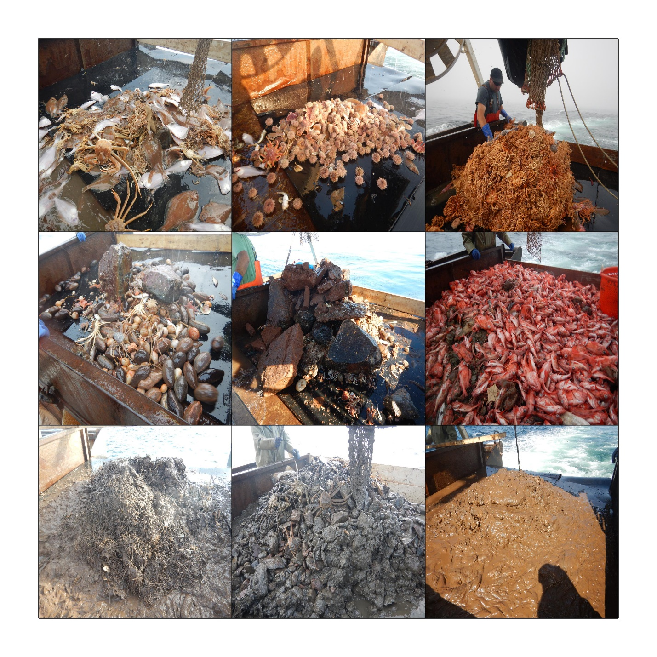

**Figure 3** : *Variety of catches encountered during the 2018 snow crab trawl survey. In reading order, the top row shows a clean catch of mainly snow crab and plaice, a large catch of sea urchins, and a large catch of basket stars; the middle row shows a catch of sea cucumbers, large rocks and a large catch of redfish; the bottom row shows large muddy catches of brittle stars, a cobble-filled catch of snow crab, and a large mud-filled catch.*



**Figure 4** : Rate of temperature change over the last 2 minutes of trawling for the headline-attached Minilog TD as a function of water depth.

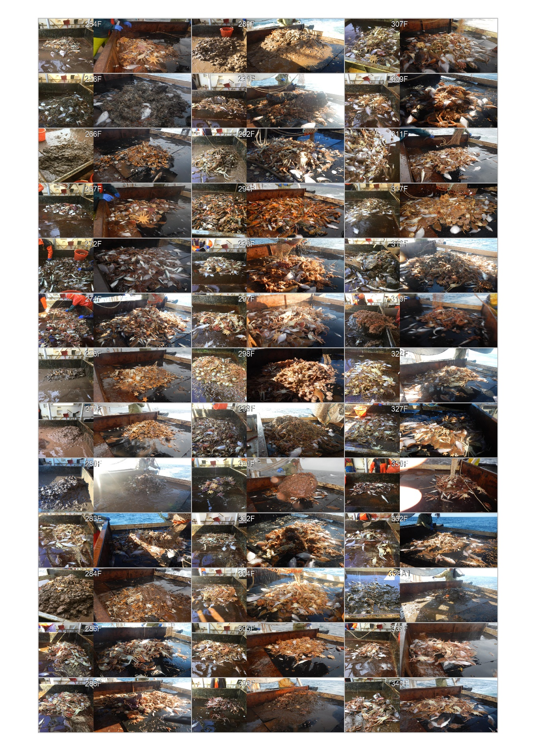

**Figure X** : Catch comparison of the Avalon Voyager II (right) and the Jean Mathieu during the 2019 comparative survey.

|  |
| --- |
|  |
| **Figure X** : Density plots of survey vessel speed observations, versus the time elapsed from the trawl touchdown, from the 2018 (left) and 2019 (right) snow crab surveys. Red lines show the median (solid line), interquartile range (dashed lines) and 95% range (dotted lines). |

|  |
| --- |
|  |
| **Figure X** : Density plots of all wing spread observations, versus the time elapsed from the trawl touchdown, from the 2018 (left) and 2019 (right) snow crab surveys. Red lines show the median (solid line), interquartile range (dashed lines) and 95% range (dotted lines). |

|  |
| --- |
|  |
| Figure X : Density plots of all headline height observations, versus the time elapsed from the trawl touchdown, from the 2018 (left) and 2019 (right) snow crab surveys. Red lines show the median (solid line), interquartile range (dashed lines) and 95% range (dotted lines). |



**Figure X** : Difference between official touchdown times and those estimated from analysis of tilt probe data. Positive values indicate that tilt values precede the official values.

* 2017 (7.7s +/- 11.3s)
* 2018 (6.6s +/- 9.2s)
* 2019 (10.6s +/- 11.8s)



**Figure X** : Vessel speed profiles for all tows during trawling in the 2017, 2018 and 2019. Darker shades show more common values. Red lines show median (solid), quartiles (dashed) and 2.5th and 97.5th percentiles (dotted). Time is relative to tilt probe touchdown time.



Speed profiles around the touchdown time derived from tilt probe.



End of tow speed profiles.







Figure X : Survey vessel tracks during the active trawling phase (grey lines) and during the passive phase (red lines). Tracks are shifted relative to the vessel position at the tilt touchdown time (center point).







Headline



Tilt









